The University of Azad Jammu and Kashmir, Muzaffarabad



Jawahir Ali
2024-SE-34
Computer Networks
Engr. Dr. Asma Javaid
Lab 01
Installation of CISCO Packet Tracer

Department Of Software Engineering
CISCO Packet Tracer
Step No: 1
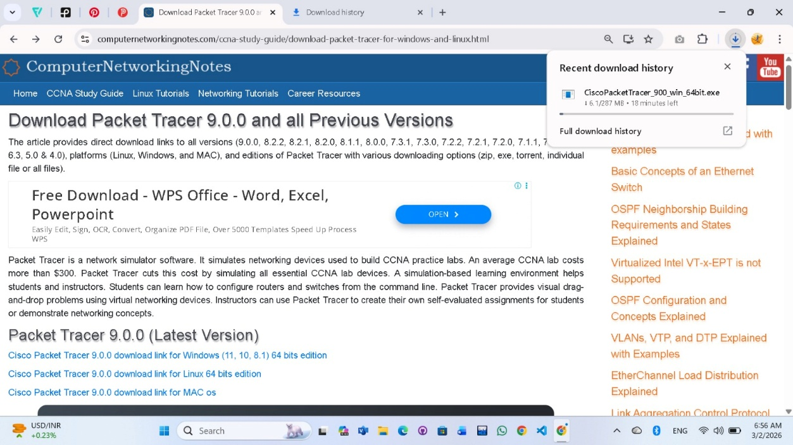

Step No: 2
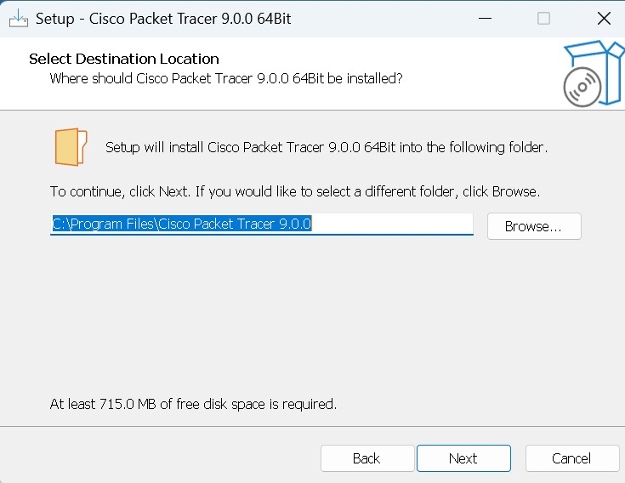

Step No: 3
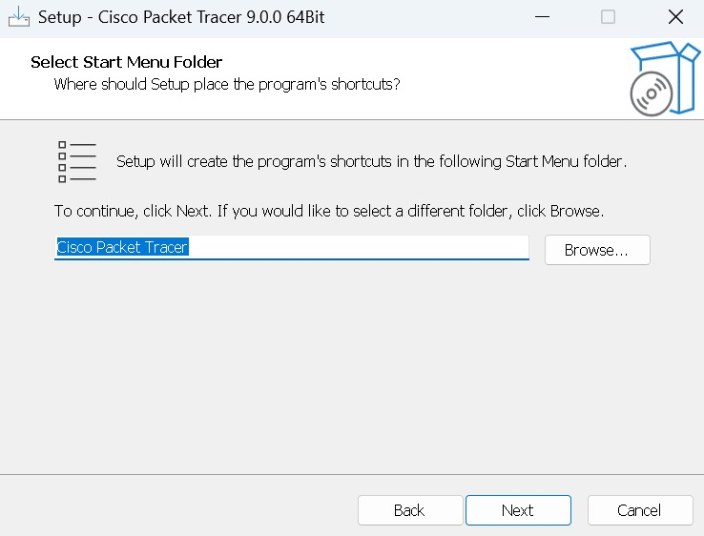

Step No: 4

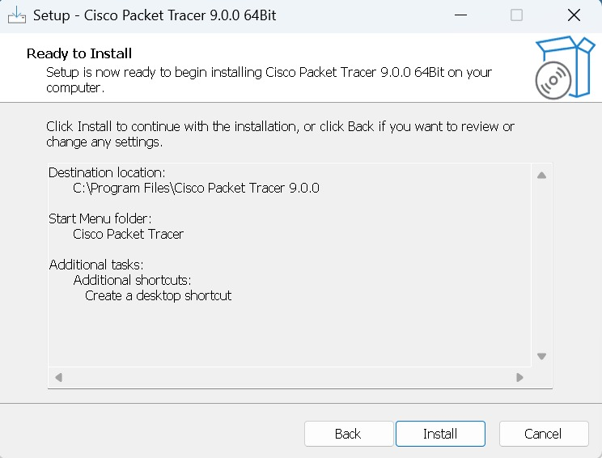
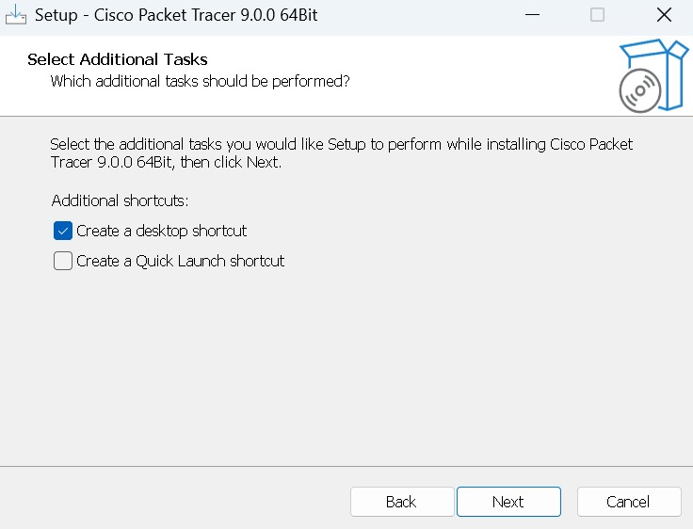

Step No: 5
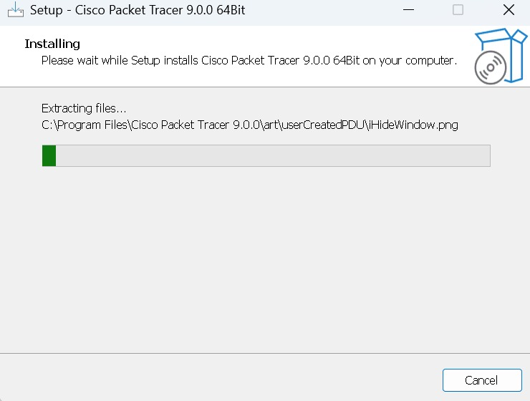
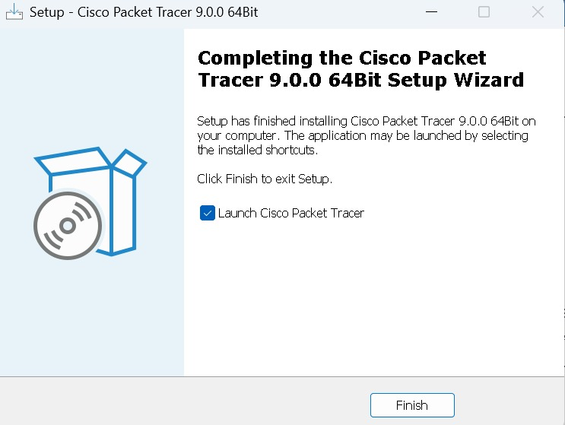

Step No: 6




